Xanvox Technologies Private Limited

Website Discussion Agenda

Date: [Insert Date]

Table of Contents – Website developer team, please go through it one by one and confirm in our next Zoom meeting.

Table of Contents

1. Introduction

2. Referral Commission Structure

3. Matching Bonus Qualification

4. Rank Bonus Qualification

5. Product Packages

6. Key Policy Updates

7. Website Enhancements

8. Policies and Procedures

-Terms and Conditions

- Code of Ethics

- Privacy Policy

- Return and Refund Policy  
- Network Solidarity Policy

-Team Building and Income Building Policy.

9. Grievance Redressal  
10. Repurchase product addition/deletion

**1. Introduction to our website to be added as follows**In dashboard, change Latest news to either ‘Welcome to XanvoxTech’ or ‘Introduction to Xanvox Technologies’ ,

**2. Referral Commission Structure Changed**(This change was promised to be done same night, please confirm if it is done so that we can announce in our team.)

Ans: Completed

- A registered promoter is eligible to get referral bonus/commission when they refer a product buyer  
-Referral Bonus correction in website as follows  
“A Promoter can earn a referral bonus of 12.5% of the product cost (₹500) for each successful referral, irrespective of activation status, provided their KYC (Know Your Customer) details are updated”  
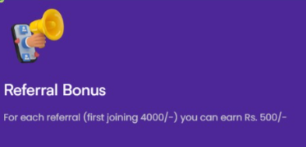

Explanation for your understanding  
- No activation (product purchase) required for referral bonuses

- KYC updating is mandatory

Ans: Yes, From starting onwards Refferal Income Generating with the above mentioned methods (Who is reffered and not checking his id is active or not). For income releasing KYC is mandatory

**3. Matching Bonus Qualification changed as follows**

(This change was promised to be done same night, please confirm if it is done so that we can announce in our team.)

- 1:1 + 1 (1 Left Direct + 1 Right Direct + 1 Indirect)  
-Matching Bonus Correction in website as follows  
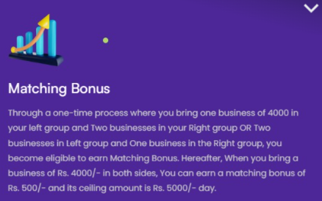

“To qualify for the Matching Bonus, a Promoter must initially generate one direct sale of ₹4,000 in both Left and Right groups and achieve one indirect sale of ₹4,000 in either group, earning a 12.5% (₹500) bonus. Thereafter, each matching pair of ₹4,000 sales (1 Left + 1 Right, direct or indirect) earns a 12.5% (₹500) bonus, with a daily maximum ceiling of ₹5,000. Matching Bonuses are paid daily.”

Ans: Yes completed, Above said corrections was done at the same day we are committed.

**4. Rank Bonus Qualification not changed but corrections required**

- 2:1 or 1:2 (3 Directs) – no change in payout plan but correction required in words used as follows.  
- In Rank Bonus, instead of using refer 1 person, 2 persons etc, kindly change it to “ when you refer one direct , 2 directs etc upto 11 directs or more” in 11 star. 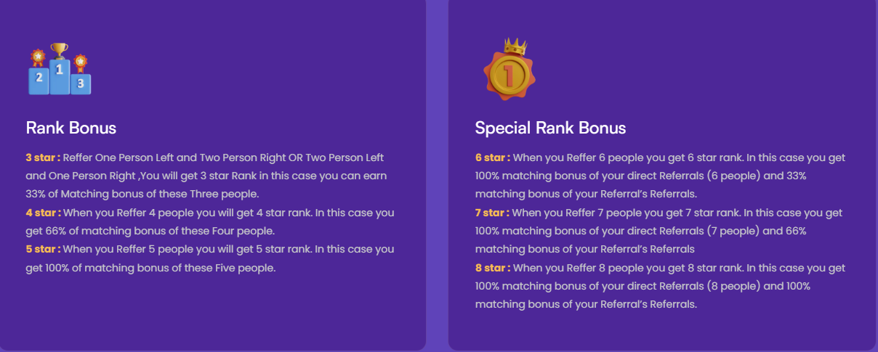  
  
  
Ans: Completed

**5. Product Packages name and package changed**

- Wondermaths Basic Maths (Book/Software/Complimentary Online Classes)

- Cost break-up: ₹4000 (Package Cost) + ₹720 (GST) + ₹100 (Shipping)

Ans: Required more explanation

**6. Key Policy Updates**

- Name correction policy: Not possible once KYC approved

- Technical correction timeline: Within 24 working hours

- Nominee option to be added

- No business center position change allowed

- Changing sponsor not possible once KYC approved

Ans: These are company decisions and company side work.

**7. Website Enhancements**  
  
- In Business Plan in website, It is good if we change all words like ‘you’ to ‘Promoter’ as it looks more professional.

Ans: Completed

- One PAN, one mobile number, one email ID per registration – Yes following same criteria

================================

- Newsroom: Events and Trainings photos, Team contest details , upcoming training calendar with image and description like date, location, time etc; uploading facility from office itself.

- Home page image updates to be done by office NSU

- Multi-language option (Google translation)  
- Login Option using either ID, Registered Mobile number or registered email ID

- Deactivation/blocking of inactive IDs within 90 days

- Change the name “star” in rewards to ‘Bronze’ - New 2025 latest updation completed  


-In this case, his total Bv count is wrong compared to his left active , why? In some cases, it is ok.Is it something to be corrected? 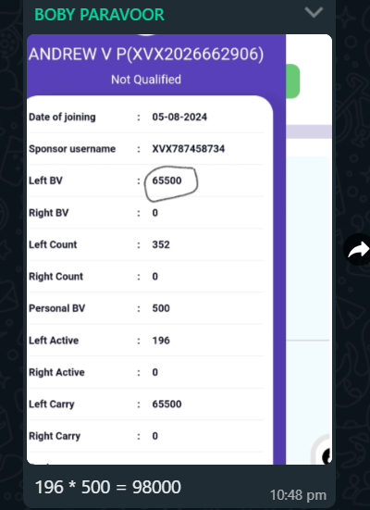  
Here it is correct

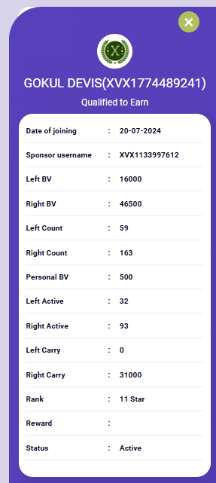  
  
- In this case, the difference in actual after carry forward does not match, please check why?  
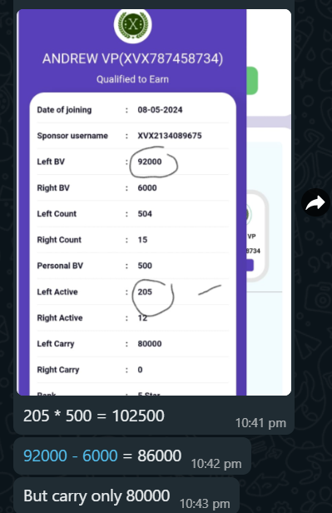

Answer: Actually no error in program, Xanvox staff confirmed no issue, Displaying error is manual tree change, effected the downline BV Values.  
  
-In Dashboard, show left Bv and right BV in same row

Answer: Completed

-We may avoid showing self BV as it is not important for us to see

-Instead please show/add Left and right Carry forward BVs here too, like showing in more option in Binary Genealogy.. Answer: Completed

-If possible, in Business Bonus, can we show the Lost/Missed Rank Bonus today and total .It creates pain, and promoter becomes more careful.

Answer: Difficult and time consuming

- Please correct me, what is the meaning of Repurchase BV will be added to Ceiling amount? Does that mean the ceiling amount will go from 5000 to a higher value? If not, correct it as

‘We offer a Repurchase Referral Bonus (RR Bonus), where the referrer himself receives 16.7% of the repurchase product billing value. Moreover, the Repurchase BVs will be added to total daily BV for all Bonus calculations. This bonus serves as an incentive for distributors to encourage repeat purchases for themselves and their downline partners.”

Answer: Completed

**8. Policies and Procedures (change title and contents as follows)**  
- Change the title word from ‘Terms and Conditions’ to Policies and Procedures with following sub titles  
Welcome to Xanvox Technologies Private Limited .We are committed to protecting the privacy and security of our customers, distributors, and website visitors.

Answer: Completed

- Add a “ I agree…” checkbox during Registration with hyperlink to ‘Policies and Procedures’ Page , which must be accepted to proceed for confirmation.  
  
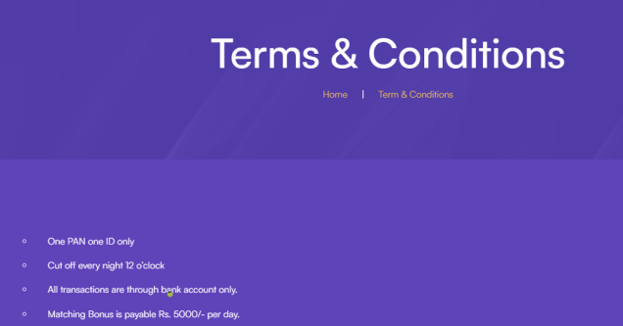

Answer: Time consuming

Subtitles

**Xanvox Technologies Private Limited**  
**1.Terms and Conditions**

- One PAN, one mobile number, one email ID only one ID

- No registration charges

- No product purchase mandatory to earn Referral Bonus

- All inactive IDs removed after 90 days

- All Bonus paid daily; cut-off time: Midnight 12 o'clock IST

- All transactions through bank account only

- Maximum Matching Bonus: ₹5000/- per day

- 5% TDS deducted from all payouts (Non-PAN 20% TDS)

- 5% Admin Charges deducted from all payouts

**2. Code of Ethics to be added as follows**

- Conduct business ethically, honestly, and lawfully

- Provide accurate product information and income disclosures

- Respect distributors' and customers' rights and privacy

- Foster a culture of inclusivity, diversity, and equal opportunity

- Prohibit deceptive or misleading practices, including pyramid schemes

- Ensure timely payment and refund processes

- Maintain confidentiality of sensitive information

- Comply with all applicable laws and regulations

- Promote responsible and sustainable business practices

- Empower distributors through training and support

**3. Return and Refund Policy**

- Full refund on product amount (excluding courier charges and GST) within 30 days

- Product return in original condition required

**4. Privacy Policy**

Effective Date: [Insert Date]

Introduction:

Xanvox Technologies Private Limited ("Xanvox" or "we" or "us") is committed to protecting the privacy and security of our customers, distributors, and website visitors. This Privacy Policy explains how we collect, use, and protect personal data.

Scope:

This Privacy Policy applies to:

1. Xanvox website(s)

2. Mobile applications

3. Direct selling activities

4. Customer and distributor interactions

Personal Data We Collect:

We collect:

1. Contact information (name, email, phone number, address)

2. Identification documents (e.g., PAN, Aadhaar)

3. Demographic information (age, location)

4. Transaction history

5. Communication records (emails, chats)

Purposes of Data Collection:

We use personal data for:

1. Registration and account management

2. Order processing and delivery

3. Customer support

4. Marketing and promotional activities

5. Compliance with legal requirements

6. Business analytics and improvement

Data Sharing:

We may share personal data with:

1. Authorized distributors and partners

2. Service providers (e.g., payment gateways)

3. Regulatory authorities (as required by law)

4. Group companies (for internal administrative purposes)

Data Security:

We implement:

1. Industry-standard encryption

2. Secure servers and data centers

3. Access controls and authentication

4. Regular security audits

Data Retention:

We retain personal data for:

1. As long as necessary for business purposes

2. As required by law

Rights of Data Subjects:

You have the right to:

1. Access and update your personal data

2. Object to processing

3. Request data deletion

4. Lodge a complaint with relevant authorities

Changes to This Policy:

We reserve the right to update this Privacy Policy. Changes will be effective immediately upon posting.

Applicable Law:

This Privacy Policy is governed by and construed in accordance with the laws of India, including the Information Technology Act, 2000, and the Information Technology (Reasonable Security Practices and Procedures and Sensitive Personal Data or Information) Rules, 2011.

Acceptance:

By using our website, mobile applications, or services, you consent to this Privacy Policy.

**5 Network Solidarity Policy Updates**

- Name correction policy: Not possible once KYC approved

- Technical correction timeline: Within 24 working hours

- Nominee option available

- No business centre position change allowed

- Changing sponsor not possible once KYC approved

- Changing ownership of business centre not possible once KYC approved, and income generated.

**6.Team Building and Income Building Policy.**

Team Building Policy of Xanvox  
- We follow an inclusive policy, where a team builder may follow his own strategies and build/develop his own team.   
- However, our Network Support Team provides common specialised trainings, regular orientation trainings, Official Zoom Business Presentation meetings etc.

Income building Policy of Xanvox  
- All Inclusive as long as no violation of Code of Ethics.  
- Anyone can follow their own strategies for sales development for the team.

**9.Grievance Redressal (editable by NSU)**

For concerns, support or grievances, please contact:

* Grievance Redressal: Mr.ABC (Head of Network Support Unit) +91 80898 92149
* Product Related Issues: +91 80898 92148
* Network Related Issues: Network Support Assistants +91 80898 92147
* Our Legal Consultant: name to be published
* Our Chartered Accountant: name to be published
* Our Company Secretary: Name to be published

**10. Repurchase product addition/deletion**  
**Maths Classes for Class 5-12**

Package 1: One-on-One

- Duration: 8 hours (2 classes/week)

- Schedule: Mutual agreement between parent and teacher (fixed days)

- Package Cost: Rs. 4000 (including GST)

- Classes: 8 x Rs. 500 = Rs. 4000

- Eligibility: One student only

- Additional classes: Available for purchase upon completion

Package 2: Group (2-4 students)

- Duration: 8 hours (2 classes/week)

- Schedule: Mutual agreement between coordinating parent and teacher (fixed days)

- Package Cost: Rs. 4800 (including GST)

- Classes: 8 x Rs. 600 = Rs. 4800

- Eligibility: 2-4 students

- Parent benefit:

- 2 students: Rs. 4800 / 2 = Rs. 2400

- 3 students: Rs. 4800 / 3 = Rs. 1600

- 4 students: Rs. 4800 / 4 = Rs. 1200

- Additional classes: Available for purchase upon completion

Terms:

- Once fixed, days cannot be changed.

- GST included in package cost.  
  
**Compensation Plan**

Self-Purchase Bonus : 16.7%

Level Bonus

- Paid to 4 upline levels

Upline Level Bonus Structure

- Level 1: 4%

- Level 2: 3%

- Level 3:2 %

- Level 4: 1%

No Other Bonuses

- No Business Volume (BV) requirements

- No Matching Bonus

- No other bonuses or incentives

**Package 1: Rs. 4000/- (including GST)**

* GST (18%): 4000 / 1.18 ≈ 3389.83 + 610.17 (GST) = 4000

Split:

* Teacher (8 classes): 2400

* Balance: 4000 - 2400 = 1600

* GST Deducted: 1600 - 610.17 = 989.83

Commission and Bonuses:

* Repurchase Bonus (16.7%): 3389.83 x 0.167 ≈ 566.10

* TDS Admin (10% of bonus): 566.10 x 0.10 ≈ 56.61

* Paid to Buyer: 566.10 - 56.61 ≈ 509.49

Remaining Balance:

* Balance: 989.83 - 566.10 ≈ 423.73

**Introducer Fees and Company Profit:**

* Introducer 1 (4%): 3389.83 x 0.04 ≈ 135.59

* Introducer 2 (3%): 3389.83 x 0.03 ≈ 101.69

* Introducer 3 (2%): 3389.83 x 0.02 ≈ 67.79

* Introducer 4 (1%): 3389.83 x 0.01 = 33.9

* Company profit: 423.73 - 135.59 - 101.69 - 67.79 - 33.9 ≈ 84.76

**Package 2: Rs. 4800/- (including GST)**

GST (18%): 4800 / 1.18 ≈ 4068.64 + 731.36 (GST) = 4800

Split:

* Teacher (8 classes): 2400

* Balance: 4800 - 2400 = 2400

* GST Deducted: 2400 - 731.36 = 1668.64

Commission and Bonuses:

* Repurchase Bonus (16.7%): 4068.64 x 0.167 ≈ 679.45

* TDS Admin (10% of bonus): 679.45 x 0.10 ≈ 67.95

* Paid to Buyer: 679.45 - 67.95 ≈ 611.50

Remaining Balance:

* Balance: 1668.64 - 679.45 ≈ 989.19

Introducer Fees and Company Profit:

*- Introducer 1 (4%): 4068.64 x 0.04 ≈ 162.75

- Introducer 2 (3%): 4068.64 x 0.03 ≈ 122.06

- Introducer 3 (2%): 4068.64 x 0.02 ≈ 81.37

- Introducer 4 (1%): 4068.64 x 0.01 ≈ 40.69

Total introducer fees: 162.75 + 122.06 + 81.37 + 40.69 ≈ 406.87

Company profit: 989.19 - 406.87 ≈ 582.32